**Airline Research**

From researching the websites of several popular airlines, I have noticed that they all follow a similar structure when it comes to booking flights.

Searching for flights

1. First, they all prompt you to search for the flight. They let you choose one-way, return or multi city flights.
2. You choose the departure airport and the destination airport (if any)
3. You choose departure date and return date (if any)
4. You are asked how many passengers you would like to book onto these flights
5. Then press the search button to see available flights.

Choosing your flight

1. Your search returns all the available time slots for your chosen dates
2. You can select the dates before and after the dates you have chosen previously
3. You can choose what time of day you would like to fly on the chosen dates
4. You can choose what class or fare type you want e.g. economy, premium, business class
5. Here you are shown what baggage you are allowed with you fare type
6. You are shown what extras come with each fare type
7. You are asked if you require and special or additional assistance with your flight
8. Usually here you can reserve a seat on the plane
9. Once you choose your time slots and fare type you can move onto contact and payment details

Contact and payment details

1. Contact details include
   1. Name
   2. Number
   3. Email
   4. Address
2. Payment details
   1. Card type
   2. Card holder name
   3. Card number
   4. Expiry date
   5. Security code

Have no research done beyond this point. Could not go any further than this on any website without having to pay for the flights.

**Ryanair**

1. Search flights
   1. Return or one way
   2. Enter airports to fly from and to
   3. Enter fly out and fly back dates
   4. Search
2. Flight details
   1. Displays dates close to your chosen date and their prices
   2. Displays departure time and airport flying from, flight time and arrival time and airport landing into
   3. Can choose what time you want to fly at from available times
   4. Can choose standard fare (no check in bag), plus (check in bag, 60 days check in, priority boarding, reserved standard seat) or flexi plus (flexible tickets, optional airport check in, fast track, 15% off travel essentials)
   5. Asked if you want to upgrade
3. Add on
   1. Reserve seat
   2. Check in bag
   3. Priority boarding
   4. Security fast track
   5. Travel insurance
   6. Parking
   7. Car hire
   8. Accommodation
   9. Equipment
4. Passenger details (Asked to login or create account)
   1. Title
   2. First name
   3. Surname
   4. Do you need special assistance?
   5. Contact details and payment
      1. Email
      2. Mobile phone
      3. SMS option
      4. Debit or credit card
      5. Card number
      6. Card type
      7. Expiry
      8. Security code
      9. Cardholder’s name
   6. Billing address
      1. Address 1
      2. Address 2
      3. City
      4. Postcode
      5. Country
   7. Terms and conditions checkbox

**Aer Lingus**

1. Search flights
   1. Airports appear when typing
   2. Airports have unique identifiers: Dublin (DUB), London-Gatwick (LGW)
   3. Choose return or one-way or multi city
   4. Enter Departing and retuning dates
   5. Can enter promotional code
   6. Choose number of passengers
2. Flight details
   1. Displays dates close to your chosen date and their prices
   2. Can choose three prices based on additional criteria (cabin bag only, checked bag and seat selection, lounge access, priority boarding and fast track through security)
   3. Displays Outbound and return flight details
   4. Details include departure time, arrival time, duration and additional details (Stopovers)
   5. Can choose what time you want to fly at from available times
3. Passenger information
   1. Title
   2. First name
   3. Family name
   4. + add special assistance
   5. **+ add frequent flyer number**
   6. If not a member, asked if you want to sign up after completing booking
   7. Contact information
      1. Email
      2. Number
      3. Asked do you want SMS confirmation of booking
      4. Asked do you want travel insurance
      5. Can choose additional baggage information or continue with booking
   8. Seat selection
   9. Checked baggage size
   10. Do you want to rent a car?
   11. Do you want lounge access?
4. Displays a summary of booking and can review it
5. Payment information
   1. Card type
   2. Card number
   3. Expiry date
   4. Cardholder information
      1. First name
      2. Family name
      3. Address line 1
      4. Address line 2
      5. City/Town
      6. Post code
      7. County/State
      8. Country
   5. Terms and conditions checkbox

**Virgin Atlantic**

Homepage

1. **Can login to Flying Club**
2. Search flights
   1. Airports appear when typing
   2. Airports have unique identifiers: Dublin (DUB), London-Gatwick (LGW)
   3. Choose return or one-way or multi city
   4. Enter Departing and retuning dates
   5. Show flights for exact dates, within 1 week, within 5 weeks
   6. Choose number of adults, young adults, children and infant tickets
   7. Payment type (Pay with card, **pay with miles, pay with miles plus money**)
3. Display flight details
   1. Displays Outbound and return flight details
   2. Details include departure time, arrival time, duration and additional details (Stopovers)
   3. **Fare types (Economy, Premium, Upper class and Delta one/Business)**
   4. Compare cabins
   5. Can choose what time you want to fly at from available times
4. Flight summary
   1. Departure date, time and fare type
   2. Return date, time and fare type
   3. Option to upgrade ticket
   4. Option to upgrade to flexible ticket (Change date, time or get refund)
   5. **Flying club**  
      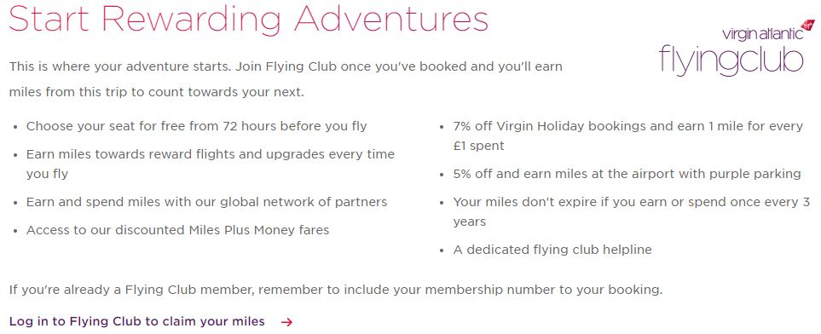
5. Details and Payment
   1. Title
   2. First name
   3. Last name
   4. DOB
   5. Gender
   6. Frequent flyer programme  
      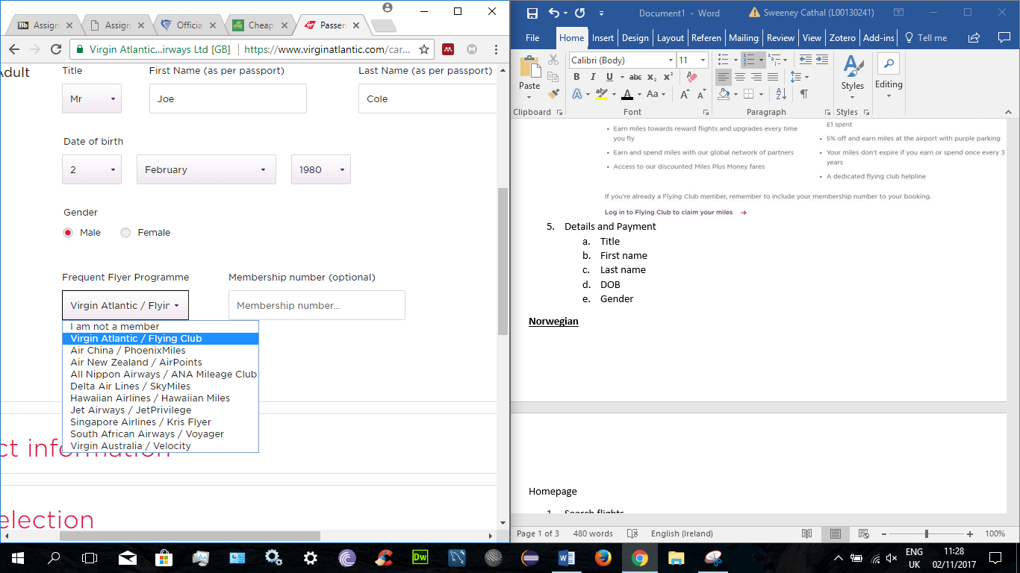
   7. Contact info
      1. Email
      2. Phone
   8. Choose or skip seat selection
   9. Payment
      1. Card number
      2. Name on card
      3. Expiry date
      4. Security code
   10. Billing address (Find address by postcode or enter manually)
       1. Country
       2. House name/number
       3. Address line 2 (Optional)
       4. City
       5. County (Optional)
       6. Postcode
   11. Terms and conditions checkbox
   12. Make payment or cancel booking

**Norwegian**

Homepage

1. Search flights
   1. Airports appear when typing
   2. Airports have unique identifiers: Dublin (DUB), London-Gatwick (LGW).
   3. Choose return or one-way
   4. Enter Outbound and return dates
   5. Choose number of adults and children tickets
   6. Can select the specific date or low fare calendar
   7. Search and book or cancel selection
2. Display flight details
   1. Displays Outbound and return flight details
   2. Details include departure time, arrival time, duration and additional details (Stopovers).
   3. **Fare types (Economy: LowFare, LowFare+, Flex, Premium: Premium, PremiumFlex)**
   4. Can choose what time you want to fly at from available times
   5. Can show previous and next day flights
   6. Can compare fare types, what each type includes (Hand & checked baggage, seat reservation, Fast track, meals, lounge, changes, refundable)
   7. Can chose special assistance for flight (Wheelchair and mobility, vision or hearing impairment, safety assistant, seating, service dogs, allergic to animals)
   8. Can view fare calendar or select start reservation
3. Asked to login or create new profile or continue unregistered

Reservation details

1. Passengers (Enter passenger details)
   1. First name
   2. Last name
   3. Gender
   4. DOB
   5. Baggage outbound (Hand baggage only, 1 bag(€35), 2 bags(€75))
   6. Baggage return (Hand baggage only, 1 bag(€47), 2 bags(€105))
   7. **Reward Number (For Norwegian reward members only)**. “Reward number is personal and provides you with the opportunity to earn CashPoints”
   8. Redress number (for travellers who have been repeatedly identified for additional screening)
   9. Telephone (mobile and home), option to receive receipt via SMS
   10. Email address for travel documents
2. Seat reservation
   1. Seat reservation + €30, then pick a seat
   2. Or continue without reservation
3. Meals
   1. 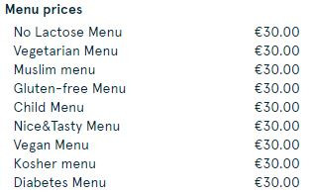
4. Additional
   1. Special baggage (Ski, golf equipment)
   2. Other special baggage and pets
   3. Cancellation protection (€12)
5. Payment
   1. Card type
   2. Card number
   3. Card holder name
   4. Expiry date
   5. Verification code (CVC)
   6. Terms and conditions checkbox.